**Career Hub Website**

**Design Document**

**Version 1.0**



**Group Id:** F24PROJECT57AAE (BC200404460)

**Supervisor Name:** Ehsan ul Haq

**Revision History**

|  |  |  |  |
| --- | --- | --- | --- |
| **Date (dd/mm/yyyy)** | **Version** | **Description** | **Tested By** |
| 24/02/2025 | 1.0 | The Career Hub Website is a platform designed to connect job seekers and employers efficiently. The platform offers a centralized space where job seekers can search for relevant opportunities and employers can post job vacancies. The website is structured to cater to three types of users: Admin, Employer, and Job Seeker. Each user has specific functionalities tailored to their role. The platform aims to simplify the hiring process by offering advanced filtering options, easy job posting mechanisms, and an admin-controlled environment for managing content. | BC200404460 |
|  |  |  |  |

**Table of Contents**

1. Introduction of Design Document 4

2. Entity Relationship Diagram 5

3. Sequence Diagram 6

3.1 Login 6

3.2 Register 7

3.3 View Jobs 7

3.4 Search Jobs 8

3.5 Add Jobs 8

3.6 Manage User 9

3.7 Manage Job Listing 10

3.8 Apply for Job 11

3.9 View Job Application 12

3.10 Logout 12

4. Architecture Design Diagram 13

5. Class Diagram 14

5. Database Design 15

7. Interface Design 16

8. Test Cases 19

# 1. Introduction of Design Document

This section should describe the design of the database or data hosting environment. The database is the repository where all of the data utilized by the system resides. It is important that the design achieves interoperability between the user facing portion of the system and the background data. This section should describe how the database is configured to achieve this. Depending on the complexity of the system, diagrams showing the database design and relationship between the database and the User interface may be helpful. It is also possible that this section references another document(s) which may contain more detailed technical data. A software design document (also known as a software design specification or technical specification documents) is a written report of a software product’s design, describing its overall architecture. Such design documents are usually written by software designers or project managers and are given to the software development team to give them an overview of what needs to be built and how. A software design document helps to ensure the design specs of the software are understood and it’s clear to all. It specifies what is possible with the product and how it can be accomplished. The purpose of this document is to outline the design for Electricians for Home Services. This will include a view of the high-level architecture as well as the breakdown of the internal subsystems. UML class and sequence diagrams will be provided to show how the system will be put together and how data will flow through the system. There will also be discussion on the technologies that we will be using throughout this project. This document provides an outline of the user interface to demonstrate how it will be formatted. The presence of documentation helps keep track of all aspects of an application and it improves on the quality of a software product. Its main focuses are development, maintenance and knowledge transfer to other developers.

**Purpose of Design Document**

The purpose of software design document is to provide a description of the design of a system fully enough to allow for software development to proceed with an understanding of what is to be built and how it is expected to build. The software design document provides information necessary to provide description of the details for the software and system to be built.

**Importance of Design Document**

Software design documents are an important way of looping everyone into the process who is involved in the product. It is for everyone to understand what is possible, what is not possible, and the system that will be designed. Design documents are created to coordinate efforts of a large team, give them a stable reference point, and describe all parts of the software and how they will operate It assures that the product is built to meet the needs and is on par with what was agreed upon prior to the inception of the product/software. Software design documents not only help others understand your system and provide documentation for future projects, but it also forces you to think through the entire system architecture.

# 2. Entity Relationship Diagram



# 3. Sequence Diagram

## 3.1 Login



## 3.2 Register



## 3.3 View Jobs



## 3.4 Search Jobs



## 3.5 Add Jobs



## 3.6 Manage User



## 3.7 Manage Job Listing



## 3.8 Apply for Job



## 3.9 View Job Application



## 3.10 Logout



# 4. Architecture Design Diagram

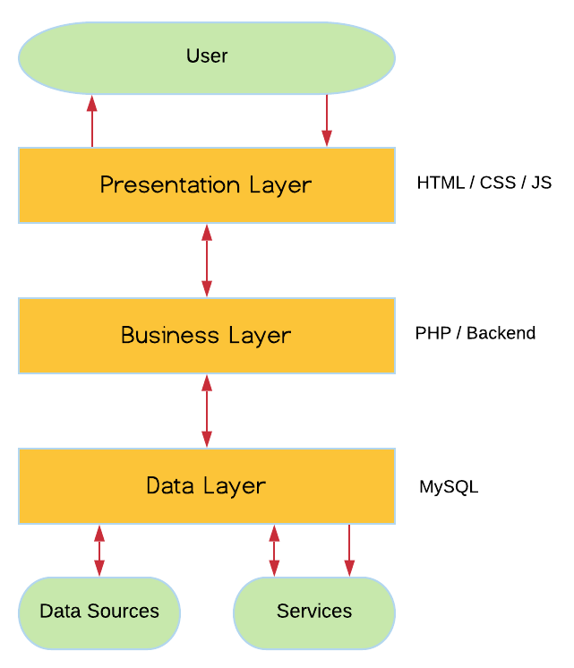

# 5. Class Diagram



# 5. Database Design



# 7. Interface Design

**Home Page**



**View Job**

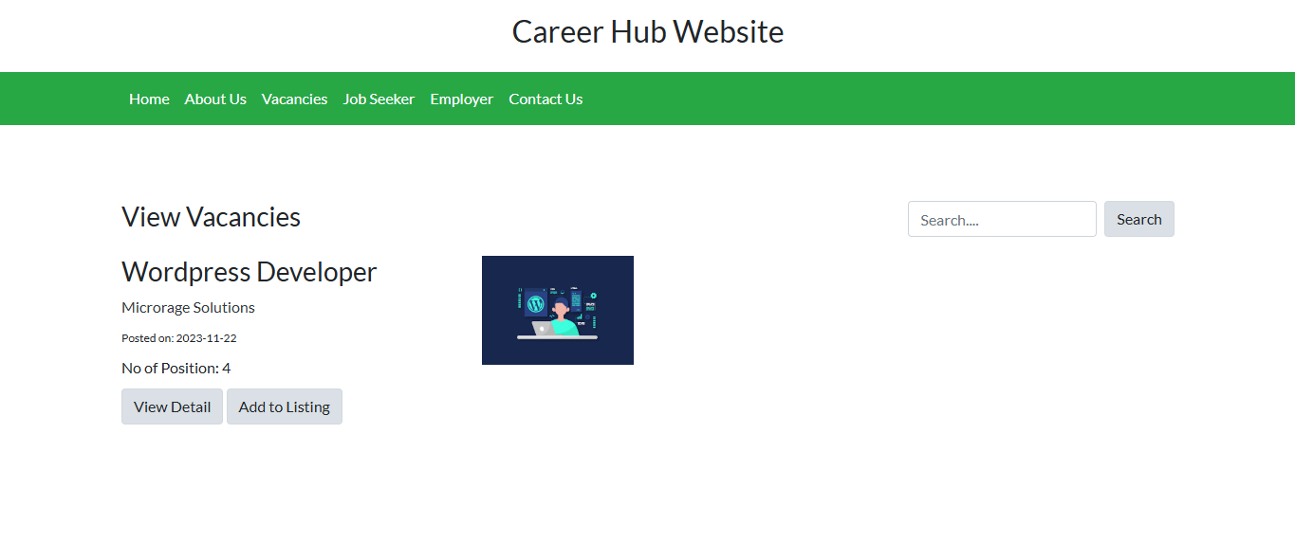

**Job Detail**



**Login**

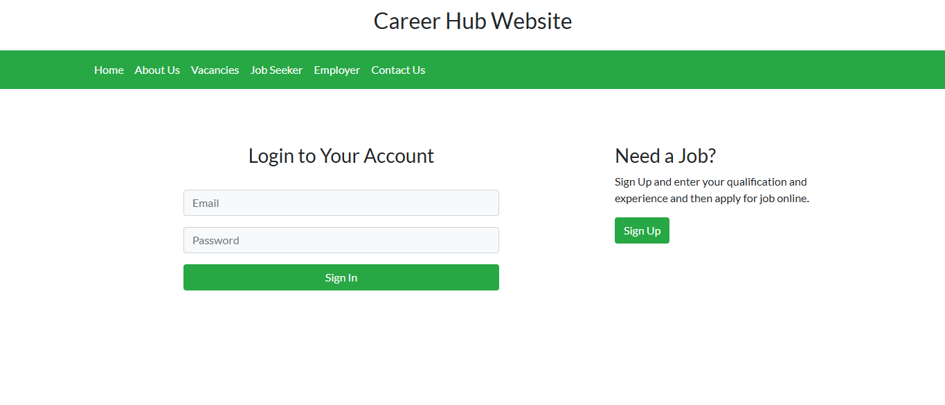

**Register**

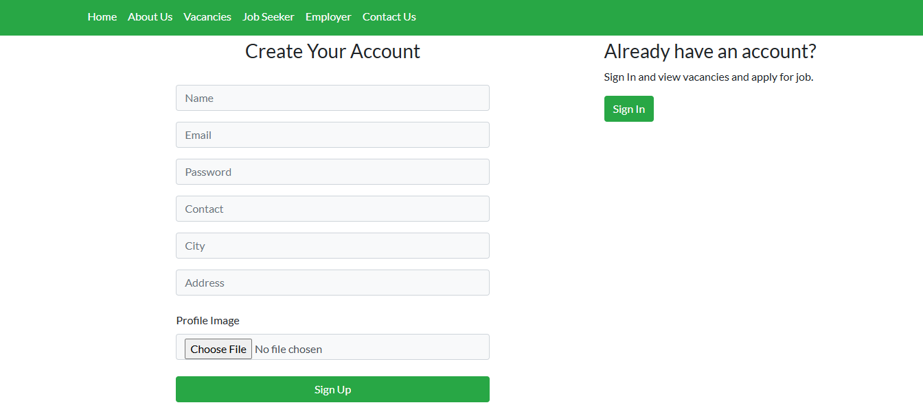

**Dashboard**

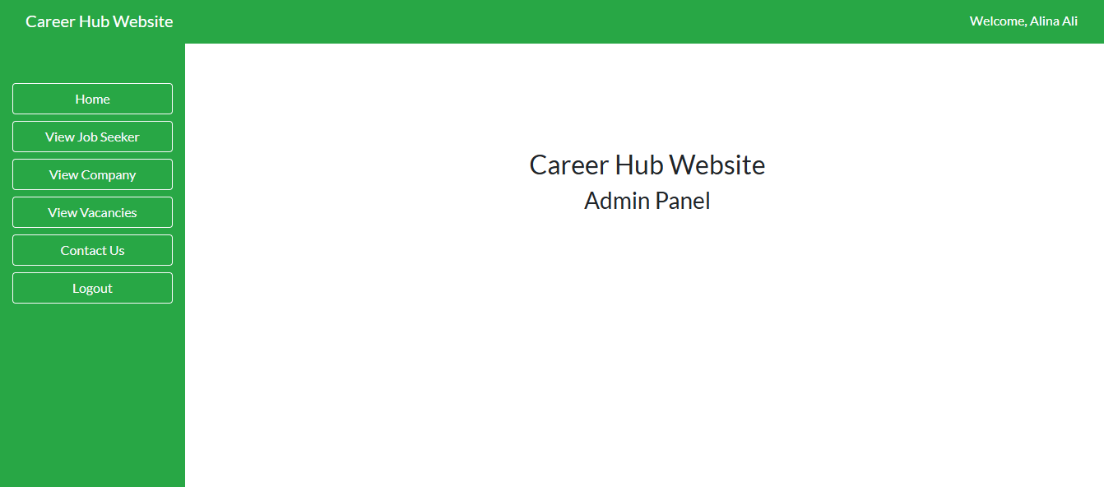

**Manage Job Seeker**

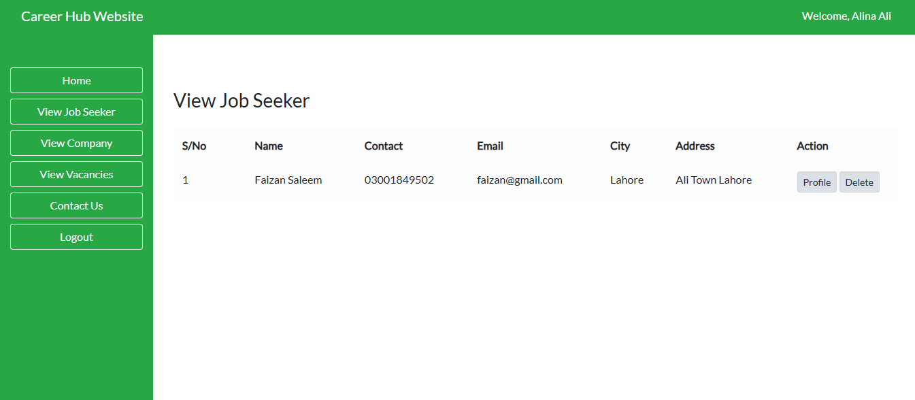

**Manage Employer**

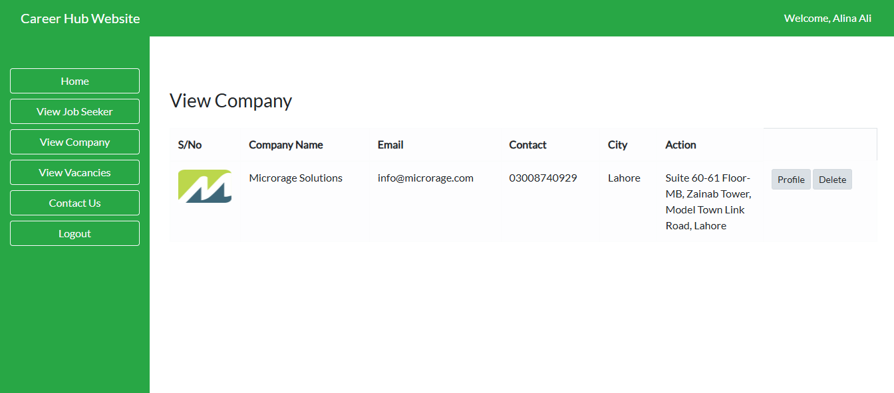

# 8. Test Cases

|  |  |
| --- | --- |
| **Test Case Title** | **Login** |
| **Test Case ID** | TC-01 |
| **Actors** | Admin, Employer, Job Seeker |
| **Description** | Allows users to log in to the system using their registered credentials (email and password). |
| **Pre-Condition** | The user must have a registered account with valid login credentials. |
| **Actions** | * User opens the login page. * User enters email and password. * System validates credentials. * User is redirected to their dashboard upon successful login. |
| **Post Condition** | The user is successfully logged in and can access their respective dashboard. |
| **Tested Result** | Pass |
| **Tested By** | BC200404460 |

|  |  |
| --- | --- |
| **Test Case Title** | **Access Dashboard** |
| **Test Case ID** | TC-02 |
| **Actors** | Admin, Employer, Job Seeker |
| **Description** | Allows users to access their respective dashboards after successfully logging in. |
| **Pre-Condition** | The user must be logged into the system. |
| **Actions** | * User selects the dashboard option after login. 2 * System identifies user role (Admin, Employer, or Job Seeker). * User is redirected to the appropriate dashboard. |
| **Post Condition** | The user successfully accesses their personalized dashboard based on their role. |
| **Tested Result** | Pass |
| **Tested By** | BC200404460 |

|  |  |
| --- | --- |
| **Test Case Title** | **Manage User** |
| **Test Case ID** | TC-03 |
| **Actors** | Admin |
| **Description** | Allows the admin to add, edit, suspend, or delete user accounts. |
| **Pre-Condition** | Admin must be logged into the system. |
| **Actions** | * Admin navigates to the "Manage Users" section. 2 * Admin selects the action (add, edit, suspend, or delete). * System processes the action and updates the user account. |
| **Post Condition** | The user account is updated, and the change is reflected in the system. |
| **Tested Result** | Pass |
| **Tested By** | BC200404460 |

|  |  |
| --- | --- |
| **Test Case Title** | **Manage Job Listings** |
| **Test Case ID** | TC-04 |
| **Actors** | Admin |
| **Description** | Allows the admin to approve, reject, or delete job postings. |
| **Pre-Condition** | Admin must be logged into the system. |
| **Actions** | * Admin navigates to the "Job Listings" section. * Admin reviews job postings. * Admin selects an action (approve, reject, or delete). * System updates the status of the job posting. |
| **Post Condition** | The job listing status is updated based on the admin's action and is reflected on the platform. |
| **Tested Result** | Pass |
| **Tested By** | BC200404460 |

|  |  |
| --- | --- |
| **Test Case Title** | **Monitor Platform Activity** |
| **Test Case ID** | TC-05 |
| **Actors** | Admin |
| **Description** | Allows the admin to view statistics and monitor platform activities such as user engagement and application metrics. |
| **Pre-Condition** | Admin must be logged into the system. |
| **Actions** | * Admin navigates to the "Platform Activity" section. * Admin selects the type of activity to monitor (e.g., user stats, job postings, applications). * System displays real-time statistics and reports. |
| **Post Condition** | Admin successfully views or downloads platform activity data. |
| **Tested Result** | Pass |
| **Tested By** | BC200404460 |

|  |  |
| --- | --- |
| **Test Case Title** | **Logout** |
| **Test Case ID** | TC-06 |
| **Actors** | Admin, Employer, Job Seeker |
| **Description** | Allows the user to log out of the system, ending their session. |
| **Pre-Condition** | The user must be logged into the system. |
| **Actions** | * User clicks on the "Logout" button. * System logs out the user and redirects to the login page. |
| **Post Condition** | User is logged out, and the session is terminated. |
| **Tested Result** | Pass |
| **Tested By** | BC200404460 |

|  |  |
| --- | --- |
| **Test Case Title** | **Manage Jobs** |
| **Test Case ID** | TC-07 |
| **Actors** | Employer |
| **Description** | Allows the employer to post, edit, or delete job listings. |
| **Pre-Condition** | Employer must be logged into the system. |
| **Actions** | * Employer navigates to the "Manage Jobs" section. * Employer selects the action (post, edit, or delete). * Employer enters job details or modifies existing ones. * System updates the job listing based on the employer's action. |
| **Post Condition** | The job listing is successfully posted, edited, or deleted, and the change is reflected on the platform. |
| **Tested Result** | Pass |
| **Tested By** | BC200404460 |

|  |  |
| --- | --- |
| **Test Case Title** | **View Job Applications** |
| **Test Case ID** | TC-08 |
| **Actors** | Employer |
| **Description** | Allows the employer to view and manage the applications received for posted job listings. |
| **Pre-Condition** | Employer must be logged into the system and have active job listings with applicants. |
| **Actions** | * Employer navigates to the "View Job Applications" section. * Employer selects a job listing to view applications. * System displays a list of applicants along with their resumes and application status. * Employer can review each application and take action (e.g., accept, reject, or shortlist). |
| **Post Condition** | Employer successfully views job applications and takes action on the applications. |
| **Tested Result** | Pass |
| **Tested By** | BC200404460 |

|  |  |
| --- | --- |
| **Test Case Title** | **Manage Hiring Process** |
| **Test Case ID** | TC-09 |
| **Actors** | Employer |
| **Description** | Allows the employer to manage the hiring process by reviewing, accepting, or rejecting candidates. |
| **Pre-Condition** | Employer must be logged into the system and have received applications for a job posting. |
| **Actions** | * Employer navigates to the "Manage Hiring Process" section. * Employer selects a job listing to manage applicants. * Employer reviews the applications and resumes. * Employer selects actions (e.g., accept, reject, shortlist) for each applicant. |
| **Post Condition** | Employer successfully manages the hiring process by updating the status of applicants. |
| **Tested Result** | Pass |
| **Tested By** | BC200404460 |

|  |  |
| --- | --- |
| **Test Case Title** | **Register** |
| **Test Case ID** | TC-10 |
| **Actors** | Job Seeker, Employer |
| **Description** | They will be able to register into the system by entering their profile information. |
| **Pre-Condition** | They must open the registration form. |
| **Actions** | * Click on register button * Enter registration detail * System will validate the information * Click on submit button |
| **Post Condition** | Users register into the system. Now they will be able to login into the system. |
| **Tested Result** | Pass |
| **Tested By** | BC200404460 |

|  |  |
| --- | --- |
| **Test Case Title** | **Upload Resume** |
| **Test Case ID** | TC-11 |
| **Actors** | Job Seeker |
| **Description** | Allows the job seeker to upload their resume in supported file formats (e.g., PDF, Word). |
| **Pre-Condition** | Job Seeker must be logged into the system and have created a profile. |
| **Actions** | * Job Seeker navigates to the "Upload Resume" section. * Job Seeker selects the resume file to upload. * Job Seeker clicks on the "Upload" button. * System validates the file format and uploads the resume. |
| **Post Condition** | Job Seeker's resume is successfully uploaded and stored in their profile. |
| **Tested Result** | Pass |
| **Tested By** | BC200404460 |

|  |  |
| --- | --- |
| **Test Case Title** | **View Jobs** |
| **Test Case ID** | TC-012 |
| **Actors** | Job Seeker |
| **Description** | Allows the job seeker to view available job listings and filter them based on their preferences. |
| **Pre-Condition** | Job Seeker must be logged into the system. |
| **Actions** | * Job Seeker navigates to the "View Jobs" section. * Job Seeker can apply filters (e.g., category, location, job type). * System displays a list of jobs based on the selected filters. * Job Seeker browses through the job listings. |
| **Post Condition** | Job Seeker successfully views the available job listings. |
| **Tested Result** | Pass |
| **Tested By** | BC200404460 |

|  |  |
| --- | --- |
| **Test Case Title** | **Search Jobs** |
| **Test Case ID** | TC-13 |
| **Actors** | Job Seeker |
| **Description** | Allows the job seeker to search for jobs using specific keywords or criteria. |
| **Pre-Condition** | Job Seeker must be logged into the system. |
| **Actions** | * Job Seeker enters keywords or search criteria in the search bar. * Job Seeker clicks on the "Search" button. * System displays job listings that match the search criteria. * Job Seeker browses through the search results. |
| **Post Condition** | Job Seeker successfully views job listings based on the search criteria. |
| **Tested Result** | Pass |
| **Tested By** | BC200404460 |

|  |  |
| --- | --- |
| **Test Case Title** | **Apply for Job** |
| **Test Case ID** | TC-14 |
| **Actors** | Job Seeker |
| **Description** | Allows the job seeker to apply for a job by submitting their resume and profile details. |
| **Pre-Condition** | Job Seeker must be logged into the system and have a complete profile with an uploaded resume. |
| **Actions** | * Job Seeker browses the job listings or uses the search function. * Job Seeker selects a job they want to apply for. * Job Seeker clicks on the "Apply" button. * Job Seeker attaches their resume (if not already uploaded) and clicks "Submit Application". * System confirms the application submission and stores it in the job seeker's application history. |
| **Post Condition** | Job Seeker's application is successfully submitted for the job, and the application is stored in their history. |
| **Tested Result** | Pass |
| **Tested By** | BC200404460 |

|  |  |
| --- | --- |
| **Test Case Title** | **View Application History** |
| **Test Case ID** | TC-15 |
| **Actors** | Job Seeker |
| **Description** | Allows the job seeker to view a list of jobs they have previously applied for, along with their application status. |
| **Pre-Condition** | Job Seeker must be logged into the system and have at least one job application submitted. |
| **Actions** | * Job Seeker navigates to the "Application History" section. * System displays a list of all jobs the Job Seeker has applied for. * Job Seeker reviews the status of each application (e.g., pending, accepted, rejected). |
| **Post Condition** | Job Seeker successfully views their application history with details on job status. |
| **Tested Result** | Pass |
| **Tested By** | BC200404460 |

|  |  |
| --- | --- |
| **Test Case Title** | **Track Application** |
| **Test Case ID** | TC-16 |
| **Actors** | Job Seeker |
| **Description** | Allows the job seeker to track the progress of their job application, including any updates from the employer. |
| **Pre-Condition** | Job Seeker must be logged into the system and have an application in progress. |
| **Actions** | * Job Seeker navigates to the "Application History" section. * Job Seeker selects a specific application they want to track. * System displays the current status and any updates from the employer (e.g., interview scheduled, rejected). |
| **Post Condition** | Job Seeker successfully tracks the status of their application and receives updates from the employer. |
| **Tested Result** | Pass |
| **Tested By** | BC200404460 |